1.Find the value of V1 in the circuit shown below?

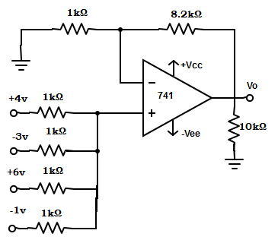

Using the superposition theorem the voltage V1 at non-inverting terminal is V1 = Va/4 + Vb/4+ Vc/4+ Vd/4 = [Va + Vb+ Vc+ Vd] /4 = [4+(-3v)+6v+(-1v) ] /4 = 1.5v.

2. In the circuit shown, supply voltage = ±15v, Va= +3v , Vb= -4v , Vc= +5v, R= R1= 1kΩ and RF= 2kΩ. 741 op-amp has A= 2×105 and R1= 10kΩ. Determine the output voltage internal resistance of the circuit?

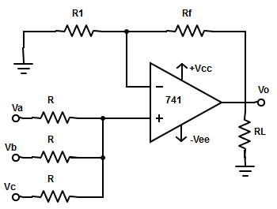

The output voltage Vo= [1 + (RF/R1)] × [ (Va+Vb+Vc/3)] = [1+(2kΩ/1kΩ)] ×[(3-4+5)/3]= 2.67 ≅ 3v.  
Internal resistance of circuit, RiF =R i [A×R1/ (R1+ RF)] = 100Ω×[(200000×1kΩ)/(1kΩ+2kΩ)] => RiF= 6.67 MΩ.

3. Consider the entire resistors in the bridge circuit are equal. The resistance and change in resistance are given as 3kΩ and 30kΩ. Calculate the output voltage of differential instrumentation amplifier?

The output voltage of the circuit is Vo =-(RF/R1)×(△R/R)×Vdc  
= (5.5kΩ/100Ω)×(30kΩ/3kΩ)×3 = 1.65v

4.  Given voltage to current converter with floating load. Determine the output current?

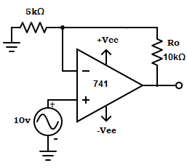

Output current, Io = Vin /R1 = 10/5kΩ =2mA.

5. Find the gain of the voltage to current converter with grounded load?

In voltage to current converter with grounded load all resistor must be equal in value.  
∴ Gain = Vo/Vin = [1+(RF/R1)] = 1+R/R =1+1=2.

6. Calculate the base voltage of Q2 transistor in the log-amp using two op-amps?

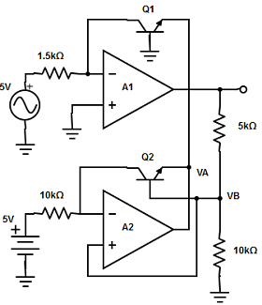

The base voltage of Q2 transistor, VB = [RTC / (R2 +RTC)]×(Vi) = [10kΩ/(5kΩ+10kΩ)]×5v =3.33v.

7.  Calculate the phase difference between two input signals applied to a multiplier, if the input signals are Vx= 2sinωt and Vy= 4sin(ωt+θ). (Take Vref= 12v).

 Vo= [Vmx×Vmy /(2×Vref)] ×cosθ  
=> (Vo×2×Vref)/ (Vmx × Vmy) = cosθ  
=> cosθ = (10×2×12)/(2×4) = 30.  
=> θ = cos-130 =1.019.

8. Determine the lower frequency limit of integration for the circuit given below.

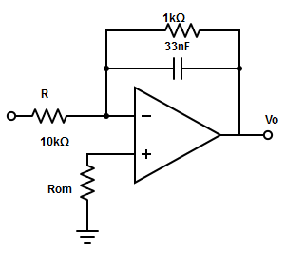

The lower frequency limit of integration, f= 1/(2πRFCF) = 1/(2π×1kΩ×33nF) = 4.82kHz.

9. A sine wave of 1vpeak at 1000Hz is applied to a differentiator with the following specification: RF =1kΩ and C1=0.33µF, find the output waveform?

Given, Vin = Vp×sinωt = sin(2π×1000)t  
The output of differentiator Vo = -RF×C1×(dVin/dt) =(1kΩ)×(0.33µF)×d[sin2π×1000t]/dt  
= -3.3×10-4×2π×1000 ×[cos2π(1000)t] =-2.07×[cos2π(1000)t].

10.  Calculate the frequency of oscillation for RC phase shift oscillator having the value of R and C as 35Ω and 3.7µF respectively.

The frequency of oscillation of RC phase shift oscillator is,  
fo=1/(2πRC√6) = 1/(2×3.14×√6×3.7µF×35Ω)  
=> fo= 1/ 1.9921×10-3 = 502Hz.

11. Calculate the value of capacitance in wein bridge oscillator, such that fo =1755Hz and R=3.3kΩ.

The frequency of oscillation is given as fo = 0.159/RC  
=> C = 0.159/R×fo = 0.159/3.3kΩ×1755Hz  
=> C = 0.027µF = 0.03µF.

12. . What will be the frequency of output waveform of a square wave generator if R2 = 1.16 R1?

When R2= 1.16 R1, then fo = 1/2RC× ln[ (2R1+ R2) / R2] = 1/2RC ×ln [(2R1 + 1.161R1 )/ (1.161R1)] = 1/( 2RC×ln2.700)= 1/2RC.

13. A square wave oscillator has fo =1khz. Assume the resistor value to be 10kΩ and find the capacitor value?

Let’s take R2 = 1.16 R2, therefore the output frequency fo = 1/2RC  
=> C = 1/2Rfo = 1/ (2×10kΩ×1khz) = 0.05µF.

14. Find the capacitor value for a the output frequency, fo = 2kHz & VO(pp) = 7v, in a triangular wave generator. The op-amp is 1458/741 and supply voltage = ±15v. (Take internal resistor=10kΩ)

Given, Vsat =15v  
∴ VO(pp) = (2R2/R3) × Vsat  
=> R2 =(VO(pp) ×R3) / (Vsat×2) = [7/(2×15)]×R3 = 0.233R3  
∵ Internal resistor, R2 = R1= 10kΩ  
=> R3 = 0.233×10kΩ = 2.33kΩ.  
So, the output frequency fO = R3 / ( 4×R1 ×C1× R2)  
=> 2khz = 2.33khz/ (4×10kΩ ×10kΩ×C1)  
=> C1 = 2.33kΩ / (8×10-11) = 2.9 ×10-9 ≅3nF.

14.  Determine the upper and lower threshold voltage

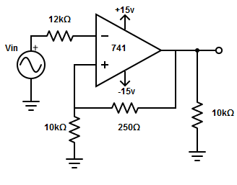

Upper threshold voltage, VUT = [R1/(R1+ R2)]× (+Vsat) = [10kΩ/(10kΩ +250Ω)]×(+15v)= +14.63v.  
Lower threshold voltage VLT = [R1/(R1+ R2)]×( -Vsat) = [10kΩ /(10kΩ+250Ω)]×(-15v)= -14.63v.

15. Calculate the hysteresis voltage for the schmitt trigger from the given specification:  
R2 =56kΩ , R1 = 100Ω ,Vref = 0v & Vsat = ±14v

Upper threshold voltage, VUT =[R1/(R1+R2)]×( +Vsat) = [100kΩ/(56kΩ +100 Ω)]×(+14v)= +25mv.  
Lower threshold voltage VLT = [R1/(R1+ R2)]×(-Vsat) = [100kΩ /(56kΩ+100Ω)]×(-14v)= -25 mv.  
∴ Hysteresis voltage = VUT-VLT = 25-(-25) = 50mv.

16.  A monostable multivibrator has R = 120kΩ and the time delay T = 1000ms, calculate the value of C?

Time delay for a monostable multivibrator, T = 1.1RC  
=> C = T/(1.1R) = 1000ms/(1.1×120kΩ) = 7.57µF.

17.  Astable multivibrator operating at 150Hz has a discharge time of 2.5m. Find the duty cycle of the circuit.

Given f=150Hz.Therefore,T=1/f =1/150 =6.67ms.  
∴ Duty cycle, D%=(tLow/T) x 100% = (2.5ms/6.67ms)x100% = 37.5%.

18.  Calculate the value of external timing capacitor, if no modulating input signal is applied to VCO. Consider fo=25 kHz and RT=5 kΩ.

When modulating input signal is not applied to VCO, the output frequency becomes fo=1/(4×RT×CT)  
=> CT =1/(4×RT×fo) =1/(4×5kΩ×25kHz) = 2×10-9 =2nF.

19. Calculate the voltage to frequency conversion factor, where fo=155Hz and Vcc=10V.

The voltage to frequency conversion factor, Kv = △fo/△Vcc= 8×fo/Vcc = (8×155)/10=124.

20.